**Task No. 1:** Write a Function to capitalize the first and last letters of each word that is input.

**Solution:**

def capitalize_first_and_last_letters(input_string):

words = input_string.split()

modified_words = []

for word in words:

if len(word) > 0:

first_letter = word[0].upper()

if len(word) > 1:

last_letter = word[-1].upper()

else:

last_letter = word[-1]

modified_word = first_letter + word[1:-1] + last_letter

modified_words.append(modified_word)

result_string = ' '.join(modified_words)

return result_string

input_string = input("Enter Any Word")

result = capitalize_first_and_last_letters(input_string)

print(result)

**Output:**

**Task No. 2:** Write a function to find common values within two lists and append in new list named "common_items". Use List comprehension for this.

**Solution:**

def CommonItemidentifier(list1,list2):

return [x for x in list1 for y in list2 if x==y ]

list1=["Ahsan"," Sajjad ","02-131212-049","5B"]

list2=["Ahsan","Sajjad","02-131212-049","BSE"]

commonitem=CommonItemidentifier(list1,list2)

print(commonitem)

**Output:**



**Task No. 3:** Write code for the task that will take user input of names of three students, along with marks of three courses . Calculate Marks obtained, Percentage and grade of each student. Append obt marks, percentage and grade in the list.

**Solution:**

def calculate_grade(percentage):

if percentage >= 90:

return "A+"

elif 80 <= percentage < 90:

return "A"

elif 70 <= percentage < 80:

return "B"

students = []

for i in range(3):

name = input(f"Enter the name of student {i + 1}: ")

marks1 = float(input("Enter marks for course 1: "))

marks2 = float(input("Enter marks for course 2: "))

marks3 = float(input("Enter marks for course 3: "))

total_marks = marks1 + marks2 + marks3

percentage = (total_marks / 300) * 100

grade = calculate_grade(percentage)

students.append({"Name": name, "Total Marks": total_marks, "Percentage": percentage, "Grade": grade})

for student in students:

print(f"Name: {student['Name']}")

print(f"Total Marks: {student['Total Marks']}")

print(f"Percentage: {student['Percentage']}%")

print(f"Grade: {student['Grade']}")

print()

**Output:**

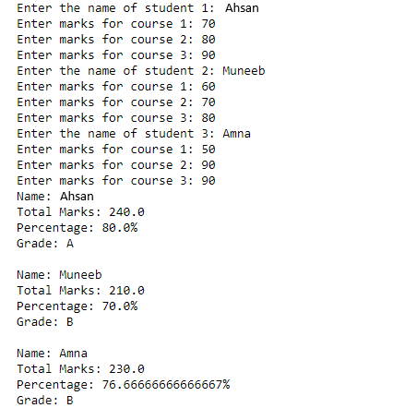

**Task No. 4:** On the basis of employees list mentioned above calculate average age of first two employees and insert that age in next two employees.

**Solution:**

employee = [

["Ayesha",24,10000,"Female"],

["Ali",20,20000,"Male"],

["Aliza",30000,"Female"],

["Hafas",40000,"Female"],

]

age=0

for item in employee[0:2]:

age+=item[1]

avg = age/2

for item in employee[2:]:

item.insert(1,avg)

**Output:**

**Task No. 5:** using the employees list mention gender wise count of  employees.

**Solution:** employee = [

["Ayesha",24,10000,"Female"],

["Ali",20,20000,"Male"],

["Aliza",30000,"Female"],

["Hafas",40000,"Female"],

]

age=0

for item in employee[0:2]:

age+=item[1]

avg = age/2

for item in employee[2:]:

item.insert(1,avg)

Gender_Count={}

for item in employee:

if item[-1] not in Gender_Count:

Gender_Count[item[-1]]=1

else: Gender_Count[item[-1]]+=1

Gender_Count

**Output:**